Topic 2 Discussion 1

How does Spring MVC support the MVC design pattern? Draw a diagram that supports the answer to this question.

A Spring MVC is a Java framework which is used to build web applications. It follows the Model-View-Controller design pattern. It implements all the basic features of a core spring framework like Inversion of Control, Dependency Injection. A Spring MVC provides an elegant solution to use MVC in spring framework by the help of **DispatcherServlet**. Here, **DispatcherServlet** is a class that receives the incoming request and maps it to the right resource such as controllers, models, and views.

* Model - A model contains the data of the application. A data can be a single object or a collection of objects.
* Controller - A controller contains the business logic of an application. Here, the @Controller annotation is used to mark the class as the controller.
* View - A view represents the provided information in a particular format. Generally, JSP+JSTL is used to create a view page. Although spring also supports other view technologies such as Apache Velocity, Thymeleaf and FreeMarker.
* Front Controller - In Spring Web MVC, the DispatcherServlet class works as the front controller. It is responsible to manage the flow of the Spring MVC application.

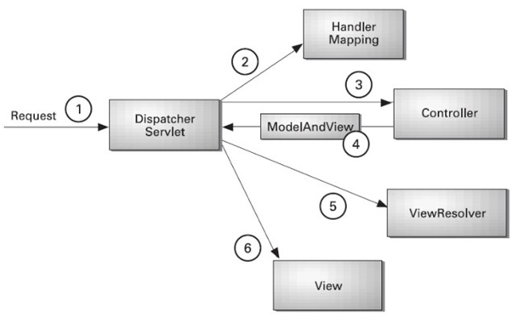

* As displayed in the figure, all the incoming request is intercepted by the DispatcherServlet that works as the front controller.
* The DispatcherServlet gets an entry of handler mapping from the XML file and forwards the request to the controller.
* The controller returns an object of ModelAndView.
* The DispatcherServlet checks the entry of view resolver in the XML file and invokes the specified view component.